**POSTMAN**

Post:

* The screenshot shows a successful POST request to the /auth/register endpoint on localhost:8080.
* where a new user with the username "Alice" was registered. The response confirms the user was created and the password was securely hashed.

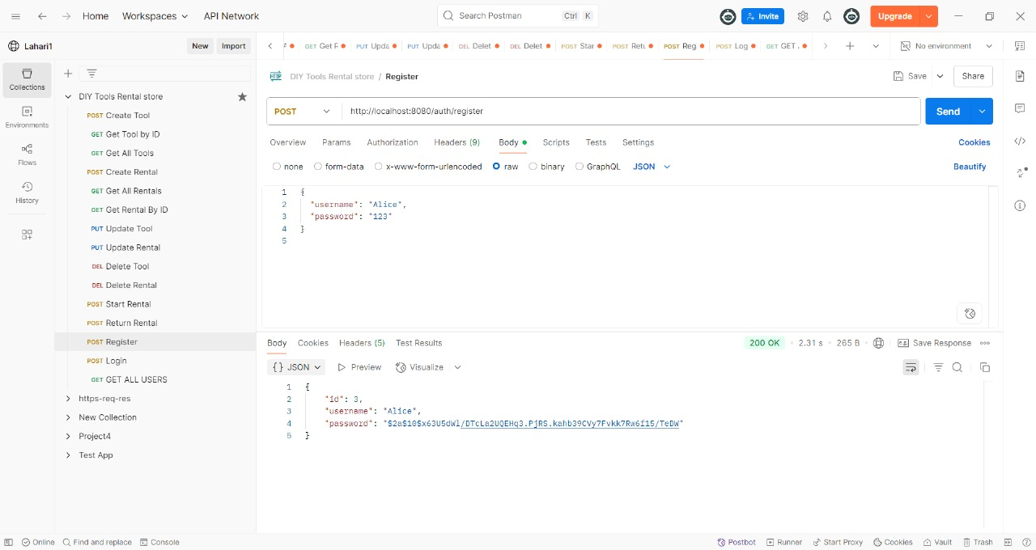

Post:

* The screenshot shows a successful login attempt via the /auth/login endpoint using the registered credentials.
* The response confirms authentication with the message "Login successful" and a 200 OK status.

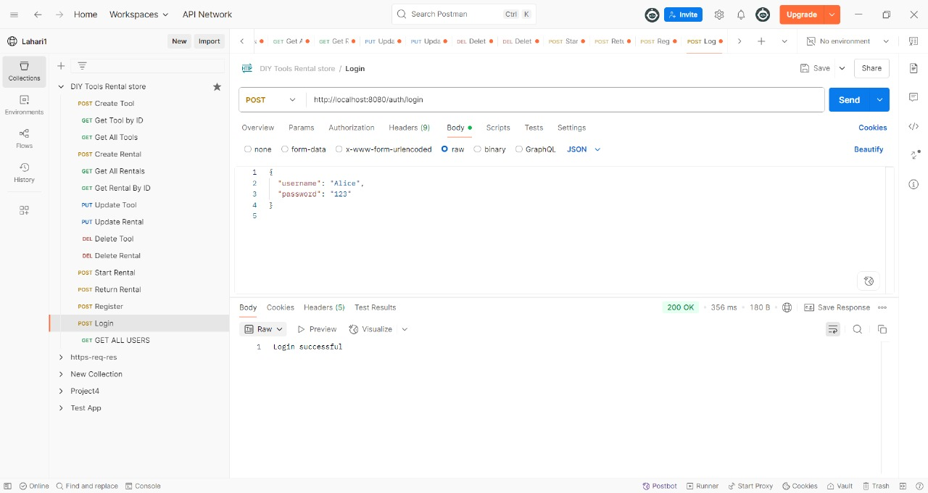

Get:

* Fetch All Users API using Postman
* This screenshot displays a successful GET request to the /auth/all endpoint, which retrieves all registered users. The response includes user details like id, username, and securely hashed passwords, confirming backend data retrieval works as expected.

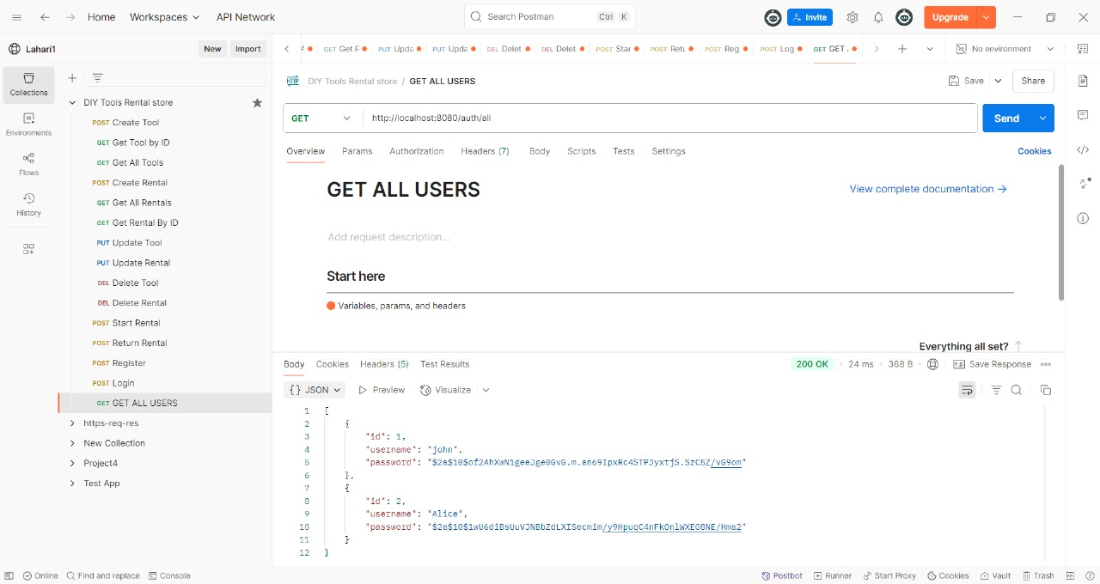

Post:

* The Postman request successfully retrieves all tools from the DIY Tools Rental store API.
* The response shows a tool with ID 1 ("Power drill") that is available for rent at a daily rate of ₹15.

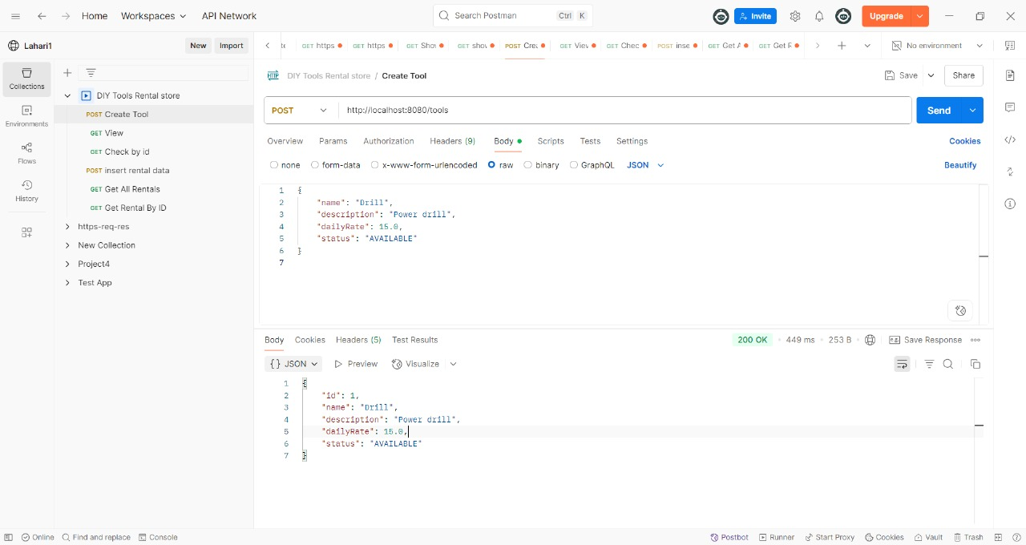

Get:

* The "Get Tool by ID" API successfully retrieves details of the tool with ID 1.
* The response shows the tool is a "Power drill" available for rent at ₹16.

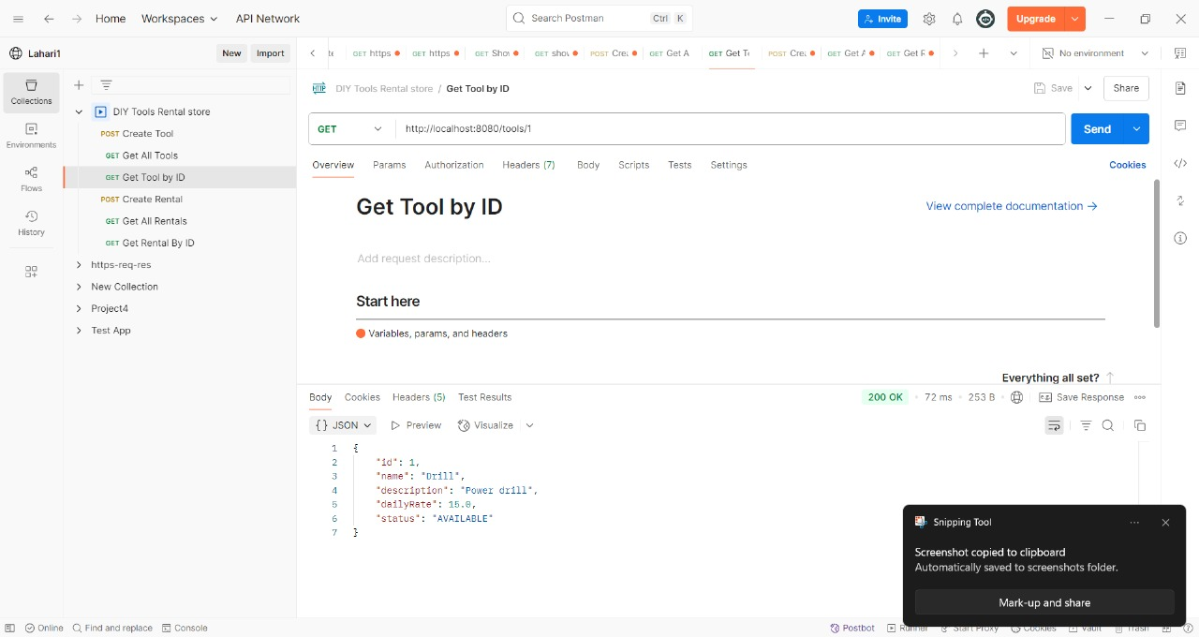

Get:

Fetch All Users API using Postman

* This screenshot displays a successful GET request which retrieves all registered users.
* The response includes user details like id, username, and securely hashed passwords, confirming backend data retrieval works as expected.



**Put:**

* The "Update Tool" API (PUT) successfully updates the tool with ID 1.
* The tool’s name, description, and daily rate are modified, confirming the updated values in the response.

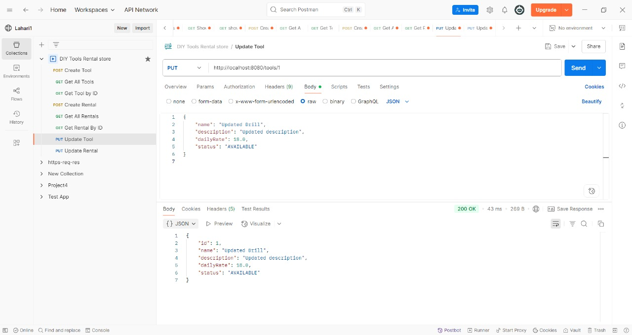

**Delete:**

* The "Delete Tool" API successfully deletes the tool with ID 3.
* The server returns a 200 OK status, indicating the request was processed correctly. The response body confirms the deletion with a simple result value of 1.

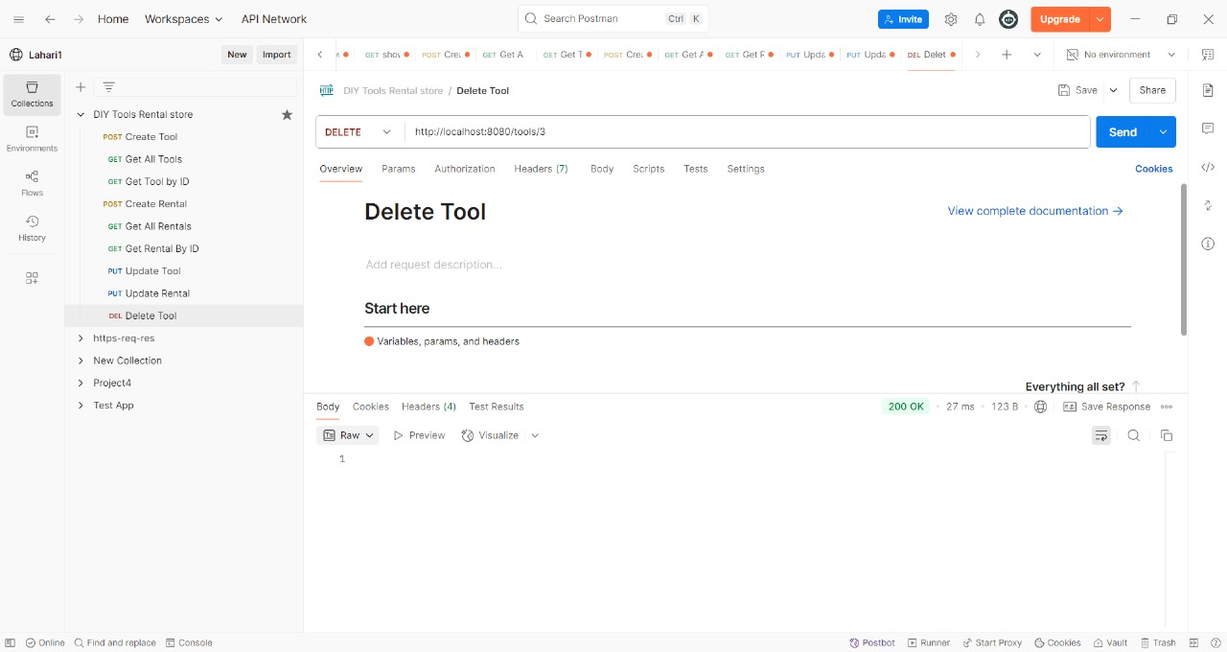

**Post:**

* The "Create Rental" API successfully registers a new rental entry for tool ID 2 by the user Alice.
* Therental is set from 2025-06-24 to 2025-06-25 with a total cost of ₹6.0. The status marked"ONGOING"

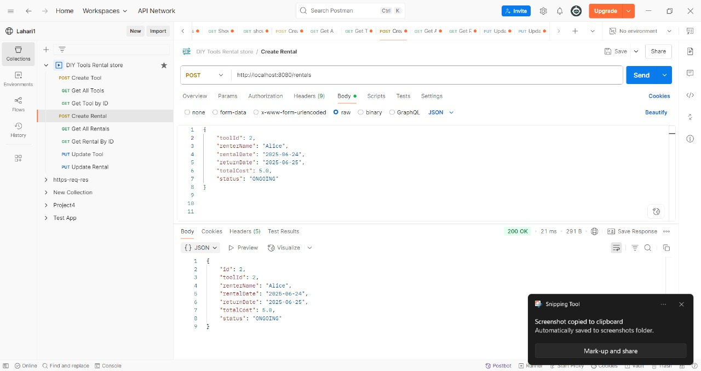

**Get:**

Fetch All Users API using Postman

* This screenshot displays a successful GET request which retrieves all registered users.
* The response includes user details like id, username, and securely hashed passwords, confirming backend data retrieval works as expected.

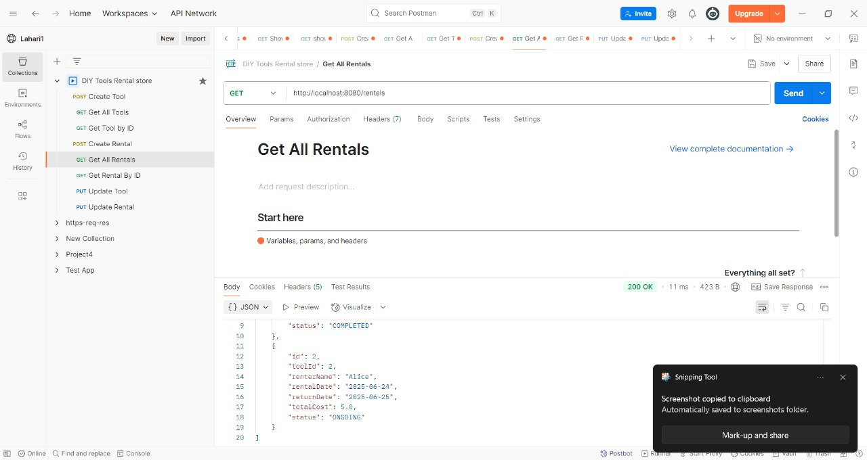

**Get:**

* The "Get Rental By ID" API retrieves details of rental ID 2.
* It confirms that Alice rented tool ID 2 from 2025-06-24 to 2025-06-25 with a status of "ONGOING".

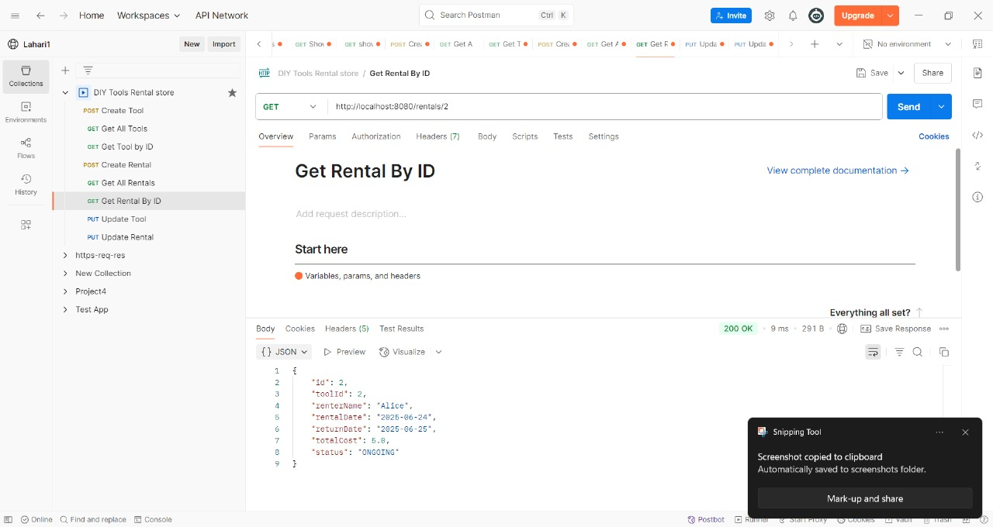

**Put:**

* The "Update Rental" API successfully updates rental ID 1.
* The tool is now marked as rented by John with updated total cost ₹10.5.
* The rental status is changed to "COMPLETED", indicating the transaction is finished.

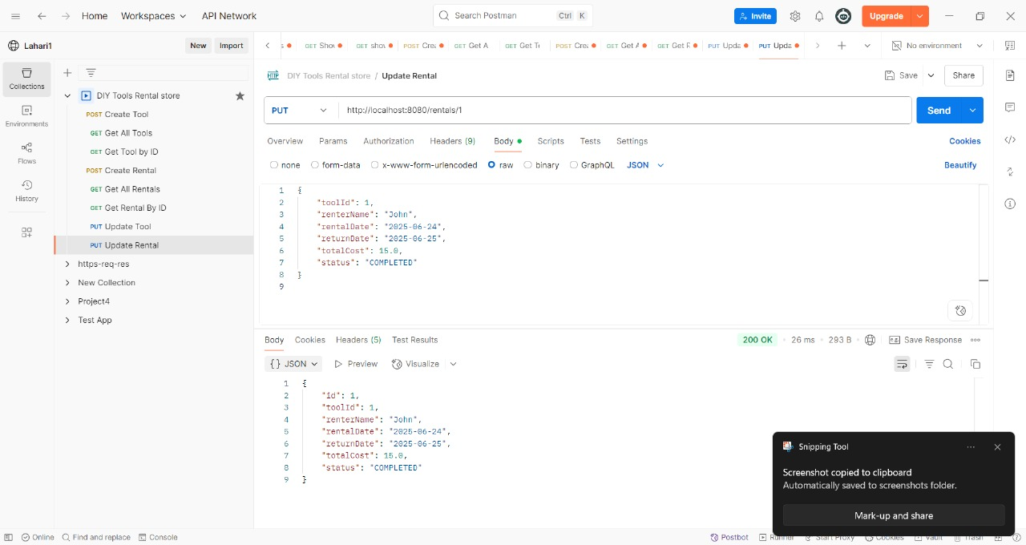

**Delete:**

* The "Delete Tool" API successfully deletes the tool with ID 3.
* The server returns a 200 OK status, indicating the request was processed correctly. The response body confirms the deletion with a simple result value of 1.

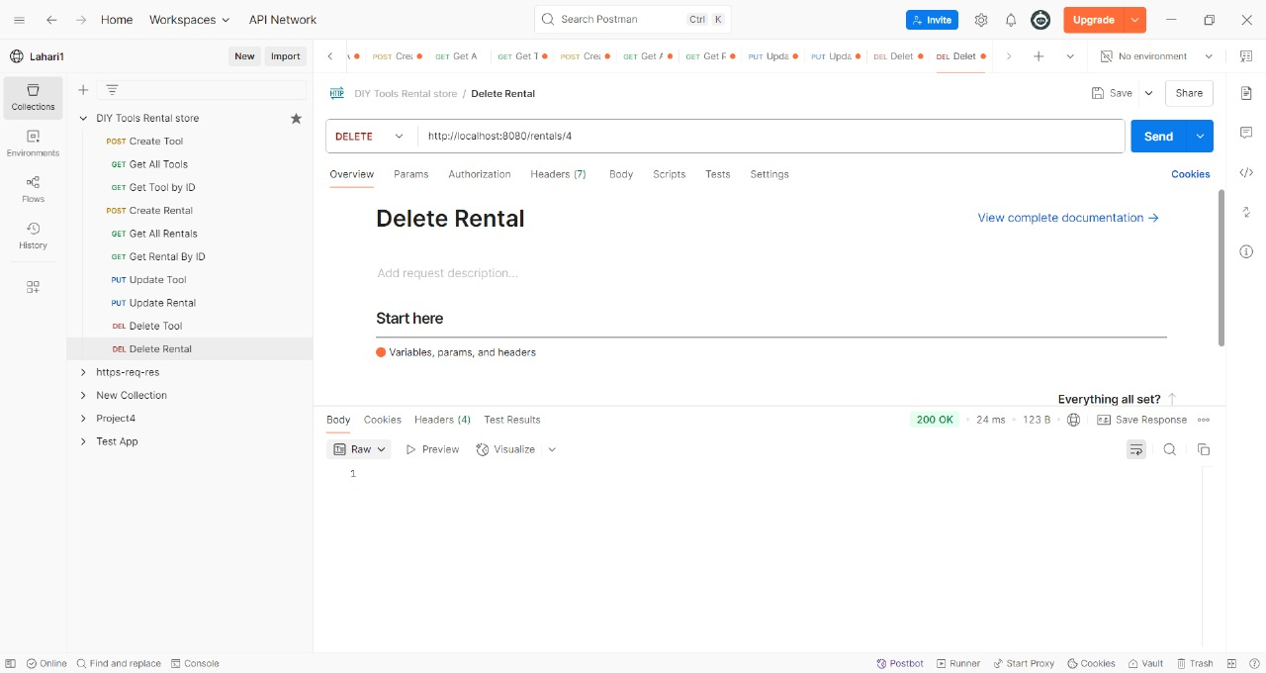

**Post:**

* Start rental marks status as ongoing and sets the rental date.

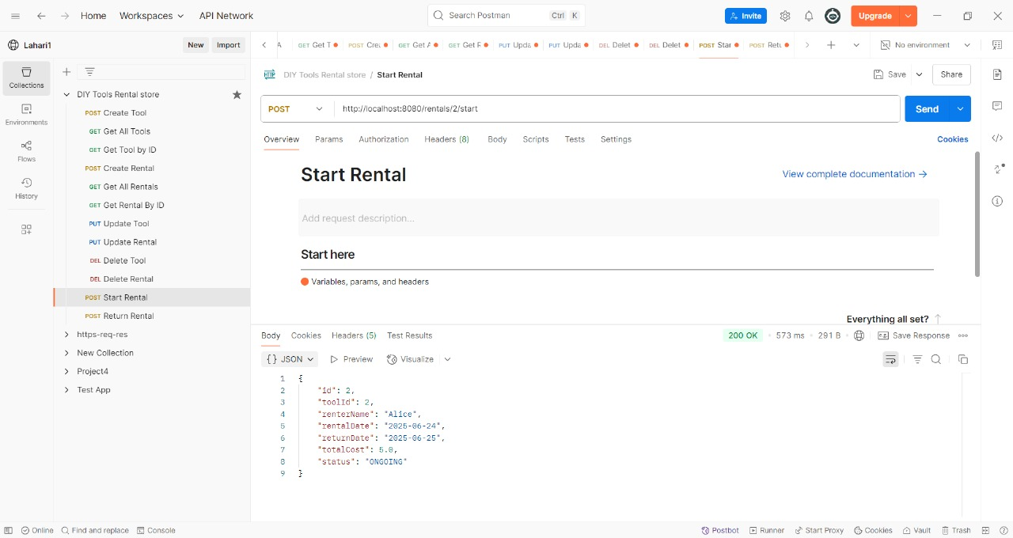

**Post :**

* Marks status as return completed and sets the return date.

